4. Online Train Reservation System
Aim
To design and develop an online train reservation system that allows passengers to search for trains, check seat availability, reserve tickets, make payments, check PNR status, cancel tickets, and receive refunds. The administrator can manage train schedules, fares, seat availability, and reservation records.
Algorithm
- Start the application.
- Allow passengers to register and log in using valid credentials.
- Accept the source station, destination station, journey date, passenger details, and travel class.
- Search for trains matching the selected journey details.
- Display available trains, timings, fares, and seat availability.
- Allow passengers to select a train and enter passenger information.
- Process the ticket payment through online or offline mode.
- Generate the ticket and PNR number after successful payment.
- Store the reservation and payment details.
- Allow passengers to check PNR status and print tickets.
- Allow passengers to cancel tickets and calculate refunds according to cancellation rules.
- Allow the administrator to manage trains, fares, schedules, and reservation records.
- Stop.

Code :
<!DOCTYPE html>
<html lang="en">
<head>
<meta charset="UTF-8">
<meta name="viewport" content="width=device-width, initial-scale=1.0">

<title>Online Train Reservation System</title>

<style>

* {
margin: 0;
padding: 0;
box-sizing: border-box;
font-family: Arial, sans-serif;
}

body {
background: #f4f6f8;
color: #333;
}

/* HEADER */

header {
background: #17365d;
color: white;
text-align: center;
padding: 22px;
}

header h1 {
margin-bottom: 8px;
}

/* NAVIGATION */

nav {
background: #0d243d;
padding: 14px;
text-align: center;
position: sticky;
top: 0;
z-index: 100;
}

nav a {
color: white;
text-decoration: none;
margin: 0 9px;
font-weight: bold;
}

nav a:hover {
color: #ffd166;
}

/* COMMON */

section {
padding: 45px 7%;
}

.title {
text-align: center;
color: #17365d;
margin-bottom: 25px;
}

.container {
max-width: 1100px;
margin: auto;
}

.btn {
display: inline-block;
background: #1479d1;
color: white;
border: none;
padding: 11px 18px;
border-radius: 5px;
cursor: pointer;
text-decoration: none;
}

.btn:hover {
background: #0c5fa8;
}

/* HERO */

.hero {
min-height: 430px;

display: flex;
align-items: center;
justify-content: center;

text-align: center;
color: white;

background:
linear-gradient(rgba(0,0,0,.6), rgba(0,0,0,.6)),
url("https://images.unsplash.com/photo-1474487548417-781cb71495f3")
center/cover;
}

.hero h2 {
font-size: 42px;
margin-bottom: 15px;
}

.hero p {
font-size: 19px;
margin-bottom: 25px;
}

/* SEARCH */

.search-box {
background: white;
padding: 25px;
border-radius: 10px;
box-shadow: 0 4px 15px #ccc;
margin-top: -40px;
position: relative;
}

.search-grid {
display: grid;
grid-template-columns: repeat(5, 1fr);
gap: 12px;
}

/* FORMS */

form {
background: white;
padding: 25px;
max-width: 850px;
margin: auto;
border-radius: 10px;
box-shadow: 0 3px 12px #ddd;
}

label {
display: block;
margin-top: 15px;
font-weight: bold;
}

input,
select,
textarea {
width: 100%;
padding: 12px;
margin-top: 6px;
border: 1px solid #ccc;
border-radius: 5px;
}

textarea {
height: 100px;
resize: vertical;
}

form .btn {
margin-top: 20px;
}

/* TRAIN CARDS */

.train-grid {
display: grid;
grid-template-columns: repeat(3, 1fr);
gap: 20px;
}

.train-card {
background: white;
border-radius: 10px;
padding: 22px;
box-shadow: 0 3px 12px #ddd;
}

.train-card h3 {
color: #17365d;
margin-bottom: 12px;
}

.train-card p {
margin: 8px 0;
}

.available {
color: green;
font-weight: bold;
}

.waiting {
color: #e67e22;
font-weight: bold;
}

/* TABLE */

.table-container {
overflow-x: auto;
}

table {
width: 100%;
border-collapse: collapse;
background: white;
box-shadow: 0 3px 12px #ddd;
}

th,
td {
padding: 13px;
border: 1px solid #ddd;
text-align: center;
}

th {
background: #17365d;
color: white;
}

tr:nth-child(even) {
background: #f5f5f5;
}

/* SEATS */

.seat-layout {
background: white;
max-width: 650px;
margin: auto;
padding: 30px;
border-radius: 10px;
box-shadow: 0 3px 12px #ddd;
}

.coach {
background: #17365d;
color: white;
padding: 12px;
text-align: center;
border-radius: 5px;
margin-bottom: 20px;
}

.seats {
display: grid;
grid-template-columns: repeat(4, 1fr);
gap: 12px;
}

.seat {
background: #4caf50;
color: white;
padding: 14px;
text-align: center;
border-radius: 5px;
font-weight: bold;
}

.seat.booked {
background: #e63946;
}

.seat.selected {
background: #f4a261;
}

/* DASHBOARD */

.dashboard {
display: grid;
grid-template-columns: repeat(4, 1fr);
gap: 20px;
}

.dashboard-card {
background: white;
padding: 25px;
text-align: center;
border-radius: 10px;
box-shadow: 0 3px 12px #ddd;
}

.dashboard-card h2 {
color: #1479d1;
font-size: 32px;
}

.dashboard-card p {
margin-top: 8px;
}

/* CARDS */

.cards {
display: grid;
grid-template-columns: repeat(3, 1fr);
gap: 20px;
}

.card {
background: white;
padding: 25px;
border-radius: 10px;
box-shadow: 0 3px 12px #ddd;
}

.card h3 {
color: #17365d;
margin-bottom: 10px;
}

.card p {
margin: 8px 0;
}

/* TICKET */

.ticket {
background: white;
max-width: 800px;
margin: auto;
padding: 30px;
border-radius: 10px;
box-shadow: 0 3px 15px #ccc;
border-left: 8px solid #1479d1;
}

.ticket-header {
text-align: center;
color: #17365d;
margin-bottom: 20px;
}

.pnr {
text-align: center;
background: #e8f4ff;
padding: 15px;
border-radius: 5px;
margin-bottom: 20px;
}

.pnr h2 {
color: #1479d1;
}

/* PROFILE */

.profile {
background: white;
max-width: 700px;
margin: auto;
padding: 30px;
border-radius: 10px;
box-shadow: 0 3px 12px #ddd;
}

.profile p {
margin: 14px 0;
}

/* FAQ */

.faq {
background: white;
max-width: 850px;
margin: 15px auto;
padding: 20px;
border-radius: 8px;
box-shadow: 0 2px 8px #ddd;
}

.faq h3 {
color: #17365d;
margin-bottom: 8px;
}

/* FOOTER */

footer {
background: #0d243d;
color: white;
text-align: center;
padding: 30px;
}

footer p {
margin: 8px;
}

/* RESPONSIVE */

@media (max-width: 900px) {

.search-grid,
.dashboard {
grid-template-columns: repeat(2, 1fr);
}

.train-grid,
.cards {
grid-template-columns: 1fr;
}
}

@media (max-width: 600px) {

nav a {
display: inline-block;
margin: 6px;
}

.search-grid,
.dashboard {
grid-template-columns: 1fr;
}

.hero h2 {
font-size: 30px;
}

.seats {
grid-template-columns: repeat(2, 1fr);
}
}

</style>
</head>

<body>

<!-- HEADER -->

<header>

<h1>🚆 Online Train Reservation System</h1>

<p>Search • Reserve • Pay • Manage Your Journey</p>

</header>

<!-- NAVIGATION -->

<nav>

<a href="#home">Home</a>

<a href="#search">Search Train</a>

<a href="#trains">Trains</a>

<a href="#booking">Book Ticket</a>

<a href="#pnr">PNR Status</a>

<a href="#mybookings">My Bookings</a>

<a href="#cancel">Cancel Ticket</a>

<a href="#login">Login</a>

<a href="#register">Register</a>

<a href="#admin">Admin</a>

</nav>

<!-- HOME -->

<section id="home" class="hero">

<div>

<h2>Online Train Reservation</h2>

<p>Search trains and book your journey easily</p>

<a href="#search" class="btn">Search Trains</a>

</div>

</section>

<!-- SEARCH TRAIN -->

<section id="search">

<h2 class="title">Search Trains</h2>

<div class="search-box">

<div class="search-grid">

<div>

<label>From Station</label>

<input
type="text"
placeholder="Origin station">

</div>

<div>

<label>To Station</label>

<input
type="text"
placeholder="Destination station">

</div>

<div>

<label>Journey Date</label>

<input type="date">

</div>

<div>

<label>Journey Time</label>

<input type="time">

</div>

<div>

<label>Class</label>

<select>

<option>All Classes</option>

<option>1A - First AC</option>

<option>2A - Second AC</option>

<option>3A - Third AC</option>

<option>SL - Sleeper</option>

<option>CC - Chair Car</option>

</select>

</div>

</div>

<br>

<center>

<button class="btn">
Search Train
</button>

</center>

</div>

</section>

<!-- AVAILABLE TRAINS -->

<section id="trains">

<h2 class="title">Available Trains</h2>

<div class="train-grid">

<div class="train-card">

<h3>🚆 Chennai Express</h3>

<p><b>Train No:</b> 12001</p>

<p><b>Route:</b> Chennai → Bangalore</p>

<p><b>Departure:</b> 06:00 AM</p>

<p><b>Arrival:</b> 11:30 AM</p>

<p><b>Duration:</b> 5h 30m</p>

<p class="available">
Available Seats: 45
</p>

<br>

<a href="#booking" class="btn">
Book Now
</a>

</div>

<div class="train-card">

<h3>🚆 Coromandel Express</h3>

<p><b>Train No:</b> 12842</p>

<p><b>Route:</b> Chennai → Kolkata</p>

<p><b>Departure:</b> 08:00 AM</p>

<p><b>Arrival:</b> 12:00 PM</p>

<p><b>Duration:</b> 28h</p>

<p class="available">
Available Seats: 32
</p>

<br>

<a href="#booking" class="btn">
Book Now
</a>

</div>

<div class="train-card">

<h3>🚆 Grand Trunk Express</h3>

<p><b>Train No:</b> 12615</p>

<p><b>Route:</b> Chennai → New Delhi</p>

<p><b>Departure:</b> 07:15 PM</p>

<p><b>Arrival:</b> 05:00 AM</p>

<p><b>Duration:</b> 33h</p>

<p class="waiting">
Waiting List: 12
</p>

<br>

<a href="#booking" class="btn">
Check Availability
</a>

</div>

</div>

</section>

<!-- TRAIN AVAILABILITY -->

<section>

<h2 class="title">
Train & Class Availability
</h2>

<div class="table-container">

<table>

<tr>

<th>Train</th>

<th>1A</th>

<th>2A</th>

<th>3A</th>

<th>Sleeper</th>

<th>Chair Car</th>

<th>Fare</th>

</tr>

<tr>

<td>Chennai Express</td>

<td>12</td>

<td>20</td>

<td>35</td>

<td>45</td>

<td>30</td>

<td>₹850</td>

</tr>

<tr>

<td>Coromandel Express</td>

<td>8</td>

<td>16</td>

<td>32</td>

<td>40</td>

<td>25</td>

<td>₹1,200</td>

</tr>

<tr>

<td>Grand Trunk Express</td>

<td>5</td>

<td>10</td>

<td>18</td>

<td>12</td>

<td>15</td>

<td>₹1,500</td>

</tr>

</table>

</div>

</section>

<!-- LOGIN -->

<section id="login">

<h2 class="title">Passenger Login</h2>

<form>

<label>
Email / Username
</label>

<input
type="text"
placeholder="Enter email or username">

<label>
Password
</label>

<input
type="password"
placeholder="Enter password">

<button class="btn">
Login
</button>

<br><br>

<a href="#">
Forgot Password?
</a>

</form>

</section>

<!-- REGISTER -->

<section id="register">

<h2 class="title">
Passenger Registration
</h2>

<form>

<label>
Full Name
</label>

<input
type="text"
placeholder="Enter full name">

<label>
Email
</label>

<input
type="email"
placeholder="Enter email">

<label>
Phone Number
</label>

<input
type="tel"
placeholder="Enter phone number">

<label>
Password
</label>

<input
type="password"
placeholder="Create password">

<label>
Confirm Password
</label>

<input
type="password"
placeholder="Confirm password">

<button class="btn">
Register
</button>

</form>

</section>

<!-- BOOK TICKET -->

<section id="booking">

<h2 class="title">
Train Ticket Booking
</h2>

<form>

<label>
Train
</label>

<select>

<option>
Chennai Express - 12001
</option>

<option>
Coromandel Express - 12842
</option>

<option>
Grand Trunk Express - 12615
</option>

</select>

<label>
Origin Station
</label>

<input
type="text"
placeholder="Enter origin station">

<label>
Destination Station
</label>

<input
type="text"
placeholder="Enter destination station">

<label>
Journey Date
</label>

<input type="date">

<label>
Class Type
</label>

<select>

<option>1A - First AC</option>

<option>2A - Second AC</option>

<option>3A - Third AC</option>

<option>SL - Sleeper</option>

<option>CC - Chair Car</option>

</select>

<label>
Number of Passengers
</label>

<input
type="number"
min="1"
max="10">

<label>
Passenger Name
</label>

<input
type="text"
placeholder="Enter passenger name">

<label>
Passenger Age
</label>

<input type="number">

<label>
Passenger Gender
</label>

<select>

<option>Male</option>

<option>Female</option>

<option>Other</option>

</select>

<label>
ID Proof Type
</label>

<select>

<option>Aadhaar Card</option>

<option>Passport</option>

<option>Driving Licence</option>

<option>Voter ID</option>

</select>

<button class="btn">
Continue Booking
</button>

</form>

</section>

<!-- SEAT SELECTION -->

<section>

<h2 class="title">
Select Seat / Berth
</h2>

<div class="seat-layout">

<div class="coach">
🚆 Coach B1
</div>

<div class="seats">

<div class="seat">01</div>

<div class="seat">02</div>

<div class="seat booked">03</div>

<div class="seat">04</div>

<div class="seat">05</div>

<div class="seat booked">06</div>

<div class="seat">07</div>

<div class="seat">08</div>

<div class="seat">09</div>

<div class="seat selected">10</div>

<div class="seat">11</div>

<div class="seat">12</div>

<div class="seat booked">13</div>

<div class="seat">14</div>

<div class="seat">15</div>

<div class="seat">16</div>

</div>

<br>

<p>🟩 Available</p>

<p>🟥 Booked</p>

<p>🟧 Selected</p>

</div>

</section>

<!-- PAYMENT -->

<section>

<h2 class="title">
Ticket Payment
</h2>

<form>

<label>
Passenger Name
</label>

<input
type="text"
value="Naveen Kumar"
readonly>

<label>
Train Fare
</label>

<input
type="text"
value="₹850"
readonly>

<label>
Payment Mode
</label>

<select>

<option>
Online Payment
</option>

<option>
UPI
</option>

<option>
Credit Card
</option>

<option>
Debit Card
</option>

<option>
Net Banking
</option>

<option>
Offline Payment
</option>

</select>

<label>
Payment Details
</label>

<input
type="text"
placeholder="Enter UPI / Card details">

<button class="btn">
Make Payment
</button>

</form>

</section>

<!-- GENERATED TICKET -->

<section>

<h2 class="title">
Confirmed Ticket
</h2>

<div class="ticket">

<div class="ticket-header">

<h2>🚆 Railway Reservation Ticket</h2>

<p>Online Train Reservation System</p>

</div>

<div class="pnr">

<p>PNR Number</p>

<h2>PNR4589213678</h2>

<p>CONFIRMED</p>

</div>

<p>
<b>Passenger:</b> Naveen Kumar
</p>

<p>
<b>Train:</b> Chennai Express
</p>

<p>
<b>Train Number:</b> 12001
</p>

<p>
<b>From:</b> Chennai Central
</p>

<p>
<b>To:</b> Bangalore
</p>

<p>
<b>Journey Date:</b> 20-10-2026
</p>

<p>
<b>Class:</b> 3A - Third AC
</p>

<p>
<b>Coach:</b> B1
</p>

<p>
<b>Seat:</b> 10
</p>

<p>
<b>Fare:</b> ₹850
</p>

<br>

<button class="btn">
🖨 Print Ticket
</button>

</div>

</section>

<!-- PNR STATUS -->

<section id="pnr">

<h2 class="title">
Check PNR Status
</h2>

<form>

<label>
Enter PNR Number
</label>

<input
type="text"
placeholder="Enter 10 digit PNR number">

<button class="btn">
Check PNR Status
</button>

</form>

<br>

<div class="ticket">

<h3>
PNR: PNR4589213678
</h3>

<br>

<p>
<b>Train:</b>
Chennai Express
</p>

<p>
<b>Journey Date:</b>
20-10-2026
</p>

<p>
<b>Passenger:</b>
Naveen Kumar
</p>

<p>
<b>Status:</b>
<span class="available">
CONFIRMED
</span>
</p>

</div>

</section>

<!-- MY BOOKINGS -->

<section id="mybookings">

<h2 class="title">
My Booking History
</h2>

<div class="table-container">

<table>

<tr>

<th>PNR</th>

<th>Train</th>

<th>Route</th>

<th>Date</th>

<th>Class</th>

<th>Seat</th>

<th>Fare</th>

<th>Status</th>

<th>Action</th>

</tr>

<tr>

<td>4589213678</td>

<td>Chennai Express</td>

<td>Chennai - Bangalore</td>

<td>20-10-2026</td>

<td>3A</td>

<td>B1-10</td>

<td>₹850</td>

<td>Confirmed</td>

<td>
<button class="btn">
Print
</button>
</td>

</tr>

<tr>

<td>3698217456</td>

<td>Coromandel Express</td>

<td>Chennai - Kolkata</td>

<td>25-10-2026</td>

<td>SL</td>

<td>S2-25</td>

<td>₹1,200</td>

<td>Confirmed</td>

<td>
<button class="btn">
Print
</button>
</td>

</tr>

</table>

</div>

</section>

<!-- CANCEL TICKET -->

<section id="cancel">

<h2 class="title">
Cancel Train Ticket
</h2>

<form>

<label>
PNR Number
</label>

<input
type="text"
placeholder="Enter PNR number">

<label>
Cancellation Reason
</label>

<textarea
placeholder="Enter cancellation reason"></textarea>

<label>
Refund Payment Mode
</label>

<select>

<option>
Original Payment Method
</option>

<option>
Bank Account
</option>

<option>
UPI
</option>

</select>

<button class="btn">
Cancel Ticket
</button>

</form>

</section>

<!-- REFUND DETAILS -->

<section>

<h2 class="title">
Refund Information
</h2>

<div class="table-container">

<table>

<tr>

<th>PNR</th>

<th>Ticket Fare</th>

<th>Cancellation Date</th>

<th>Refund Percentage</th>

<th>Refund Amount</th>

<th>Status</th>

</tr>

<tr>

<td>4589213678</td>

<td>₹850</td>

<td>10-10-2026</td>

<td>80%</td>

<td>₹680</td>

<td>Processing</td>

</tr>

<tr>

<td>3698217456</td>

<td>₹1,200</td>

<td>05-10-2026</td>

<td>90%</td>

<td>₹1,080</td>

<td>Refunded</td>

</tr>

</table>

</div>

</section>

<!-- PASSENGER PROFILE -->

<section>

<h2 class="title">
Passenger Profile
</h2>

<div class="profile">

<h3>Passenger Information</h3>

<p>
<b>Name:</b>
Naveen Kumar
</p>

<p>
<b>Email:</b>
naveen@example.com
</p>

<p>
<b>Phone:</b>
9876543210
</p>

<p>
<b>Total Bookings:</b>
8
</p>

<p>
<b>Cancelled Tickets:</b>
2
</p>

<button class="btn">
Edit Profile
</button>

</div>

</section>

<!-- ADMIN DASHBOARD -->

<section id="admin">

<h2 class="title">
Railway Admin Dashboard
</h2>

<div class="dashboard">

<div class="dashboard-card">

<h2>85</h2>

<p>Total Trains</p>

</div>

<div class="dashboard-card">

<h2>2,450</h2>

<p>Total Seats</p>

</div>

<div class="dashboard-card">

<h2>1,280</h2>

<p>Registered Users</p>

</div>

<div class="dashboard-card">

<h2>540</h2>

<p>Today's Bookings</p>

</div>

</div>

</section>

<!-- ADMIN TRAIN MANAGEMENT -->

<section>

<h2 class="title">
Manage Train Details
</h2>

<div class="table-container">

<table>

<tr>

<th>Train No</th>

<th>Train Name</th>

<th>From</th>

<th>To</th>

<th>Departure</th>

<th>Arrival</th>

<th>Action</th>

</tr>

<tr>

<td>12001</td>

<td>Chennai Express</td>

<td>Chennai</td>

<td>Bangalore</td>

<td>06:00 AM</td>

<td>11:30 AM</td>

<td>

<button class="btn">
Edit
</button>

<button class="btn">
Delete
</button>

</td>

</tr>

<tr>

<td>12842</td>

<td>Coromandel Express</td>

<td>Chennai</td>

<td>Kolkata</td>

<td>08:00 AM</td>

<td>12:00 PM</td>

<td>

<button class="btn">
Edit
</button>

<button class="btn">
Delete
</button>

</td>

</tr>

</table>

</div>

</section>

<!-- ADD / UPDATE TRAIN -->

<section>

<h2 class="title">
Add / Update Train
</h2>

<form>

<label>
Train Number
</label>

<input
type="text"
placeholder="Enter train number">

<label>
Train Name
</label>

<input
type="text"
placeholder="Enter train name">

<label>
Origin Station
</label>

<input
type="text"
placeholder="Enter origin station">

<label>
Destination Station
</label>

<input
type="text"
placeholder="Enter destination station">

<label>
Departure Time
</label>

<input type="time">

<label>
Arrival Time
</label>

<input type="time">

<label>
Train Date
</label>

<input type="date">

<label>
Train Class
</label>

<select>

<option>1A - First AC</option>

<option>2A - Second AC</option>

<option>3A - Third AC</option>

<option>SL - Sleeper</option>

<option>CC - Chair Car</option>

</select>

<label>
Total Seats
</label>

<input type="number">

<label>
Available Seats
</label>

<input type="number">

<label>
Fare
</label>

<input
type="number"
placeholder="Enter fare">

<button class="btn">
Add Train
</button>

<button class="btn">
Update Train
</button>

</form>

</section>

<!-- ADMIN USER MANAGEMENT -->

<section>

<h2 class="title">
Manage Passengers
</h2>

<div class="table-container">

<table>

<tr>

<th>User ID</th>

<th>Name</th>

<th>Email</th>

<th>Phone</th>

<th>Bookings</th>

<th>Status</th>

<th>Action</th>

</tr>

<tr>

<td>U001</td>

<td>Naveen Kumar</td>

<td>naveen@example.com</td>

<td>9876543210</td>

<td>8</td>

<td>Active</td>

<td>
<button class="btn">
View
</button>
</td>

</tr>

<tr>

<td>U002</td>

<td>Rahul</td>

<td>rahul@example.com</td>

<td>9876501234</td>

<td>5</td>

<td>Active</td>

<td>
<button class="btn">
View
</button>
</td>

</tr>

</table>

</div>

</section>

<!-- ADMIN PNR MANAGEMENT -->

<section>

<h2 class="title">
PNR & Booking Management
</h2>

<div class="table-container">

<table>

<tr>

<th>PNR</th>

<th>Passenger</th>

<th>Train</th>

<th>Journey Date</th>

<th>Class</th>

<th>Seat</th>

<th>Status</th>

<th>Action</th>

</tr>

<tr>

<td>4589213678</td>

<td>Naveen Kumar</td>

<td>Chennai Express</td>

<td>20-10-2026</td>

<td>3A</td>

<td>B1-10</td>

<td>Confirmed</td>

<td>
<button class="btn">
View
</button>
</td>

</tr>

<tr>

<td>3698217456</td>

<td>Rahul</td>

<td>Coromandel Express</td>

<td>25-10-2026</td>

<td>SL</td>

<td>S2-25</td>

<td>RAC</td>

<td>
<button class="btn">
View
</button>
</td>

</tr>

</table>

</div>

</section>

<!-- FARE MANAGEMENT -->

<section>

<h2 class="title">
Fare Management
</h2>

<form>

<label>
Train
</label>

<select>

<option>
Chennai Express
</option>

<option>
Coromandel Express
</option>

<option>
Grand Trunk Express
</option>

</select>

<label>
Zone
</label>

<select>

<option>South Zone</option>

<option>East Zone</option>

<option>North Zone</option>

<option>West Zone</option>

</select>

<label>
Class
</label>

<select>

<option>1A</option>

<option>2A</option>

<option>3A</option>

<option>Sleeper</option>

<option>Chair Car</option>

</select>

<label>
Journey Date
</label>

<input type="date">

<label>
Fare Amount
</label>

<input
type="number"
placeholder="Enter fare">

<button class="btn">
Update Fare
</button>

</form>

</section>

<!-- REFUND RULE MANAGEMENT -->

<section>

<h2 class="title">
Refund Rules Management
</h2>

<div class="table-container">

<table>

<tr>

<th>Cancellation Period</th>

<th>Ticket Fare</th>

<th>Refund Percentage</th>

<th>Action</th>

</tr>

<tr>

<td>More than 48 hours</td>

<td>Any Fare</td>

<td>90%</td>

<td>
<button class="btn">
Edit
</button>
</td>

</tr>

<tr>

<td>24 - 48 hours</td>

<td>Any Fare</td>

<td>80%</td>

<td>
<button class="btn">
Edit
</button>
</td>

</tr>

<tr>

<td>Less than 24 hours</td>

<td>Any Fare</td>

<td>50%</td>

<td>
<button class="btn">
Edit
</button>
</td>

</tr>

</table>

</div>

</section>

<!-- REPORTS -->

<section>

<h2 class="title">
Generate Reports
</h2>

<form>

<label>
Report Type
</label>

<select>

<option>
Daily Booking Report
</option>

<option>
Monthly Booking Report
</option>

<option>
Train Availability Report
</option>

<option>
Passenger Report
</option>

<option>
Cancellation Report
</option>

<option>
Payment Report
</option>

<option>
Refund Report
</option>

</select>

<label>
From Date
</label>

<input type="date">

<label>
To Date
</label>

<input type="date">

<button class="btn">
Generate Report
</button>

</form>

</section>

<!-- FAQ -->

<section>

<h2 class="title">
Frequently Asked Questions
</h2>

<div class="faq">

<h3>
How can I book a train ticket?
</h3>

<p>
Login to your account, search for a train,
select the class and seat, enter passenger
details and complete the payment.
</p>

</div>

<div class="faq">

<h3>
What is PNR?
</h3>

<p>
PNR is the unique Passenger Name Record
number generated after a successful booking.
</p>

</div>

<div class="faq">

<h3>
How can I check my PNR status?
</h3>

<p>
Enter your PNR number in the PNR Status
section to view the booking status.
</p>

</div>

<div class="faq">

<h3>
Can I cancel my ticket?
</h3>

<p>
Yes. Enter your PNR number and submit
a cancellation request.
</p>

</div>

</section>

<!-- CONTACT -->

<section>

<h2 class="title">
Contact Railway Support
</h2>

<form>

<label>
Name
</label>

<input
type="text"
placeholder="Enter your name">

<label>
Email
</label>

<input
type="email"
placeholder="Enter email">

<label>
Subject
</label>

<input
type="text"
placeholder="Enter subject">

<label>
Message
</label>

<textarea
placeholder="Enter your message"></textarea>

<button class="btn">
Send Message
</button>

</form>

</section>

<!-- FOOTER -->

<footer>

<h3>
🚆 Online Train Reservation System
</h3>

<p>
Search • Reserve • Pay • Check PNR • Cancel
</p>

<p>
© 2026 Online Train Reservation System
</p>

</footer>

</body>
</html>
Output :
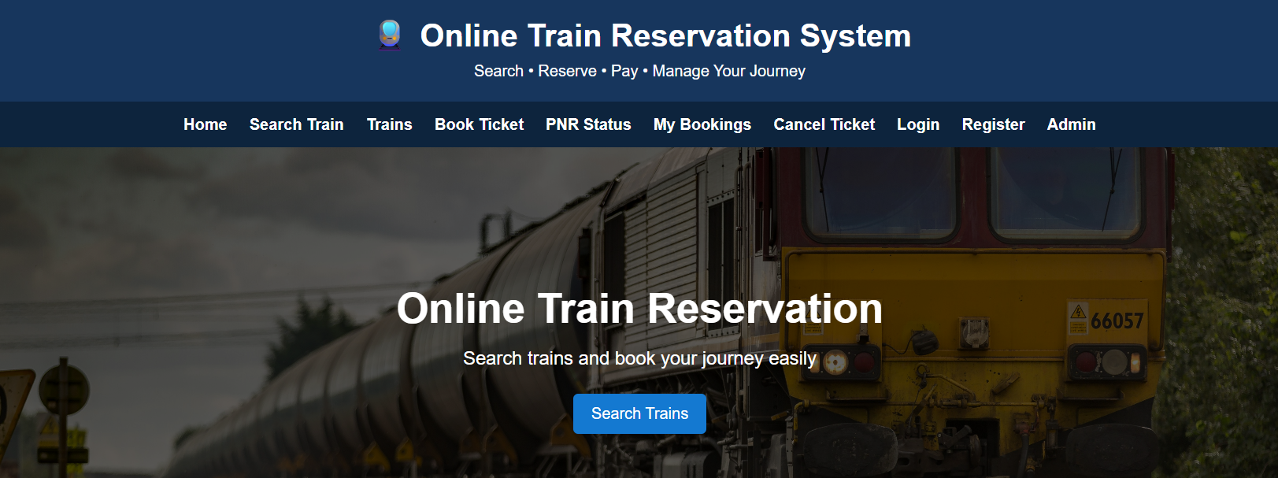
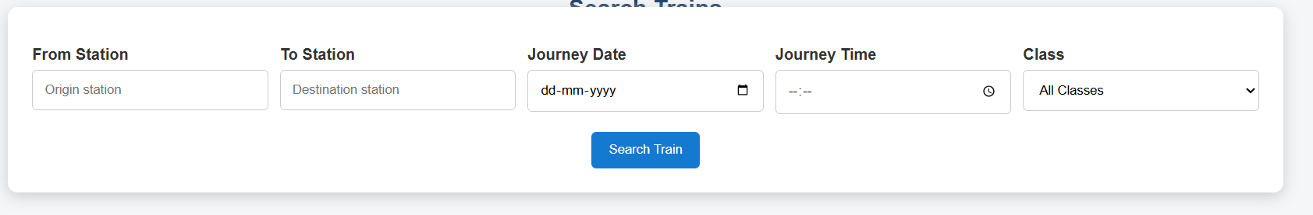
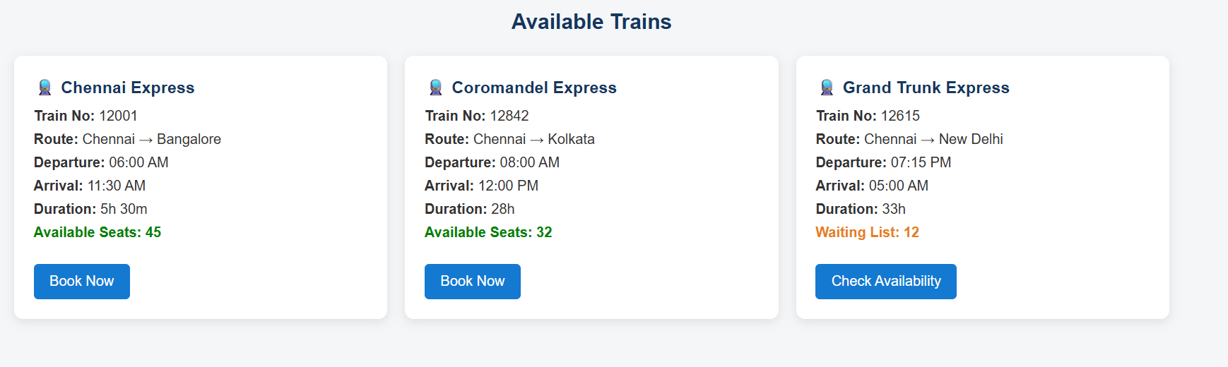
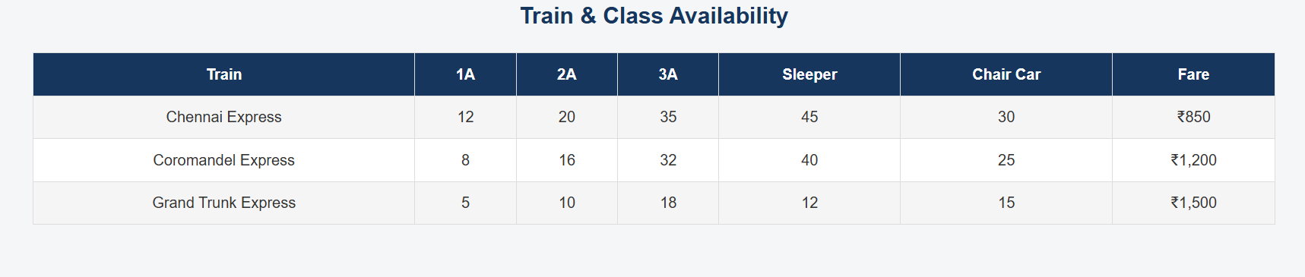
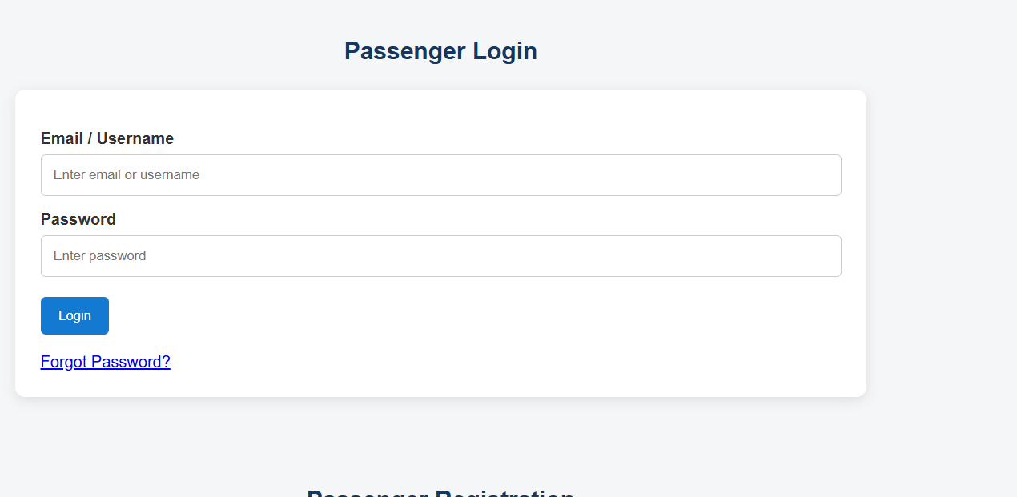
Result : Online Train Reservation System successfully designed

